

Name: Sajjal Tariq

Roll no: 10011

Section: A (BSCS)

Subject: Computer Organization Assembly Language

LAB NO: 01

- Start the computer; go to the BIOS menu by pressing the F2 key on the keyboard. Record information like
  - Motherboard’s model and manufacturer
  - Microprocessor’s model and manufacturer
  - Installed RAM
  - Installed hard disk drives, etc
The system information was collected using the BIOS/System Information utility. The motherboard model and manufacturer, processor details, installed RAM, and storage device were recorded. Screenshots were captured and attached as evidence.

Component | Details
Motherboard Manufacturer | Dell Inc.
Motherboard Model | Latitude 5410
Processor Manufacturer | Intel
Processor Model | Intel Core i5-10210U (10th Gen)
Installed RAM | 8 GB DDR4
Storage Device | 256 GB SSD
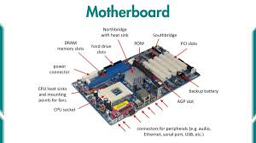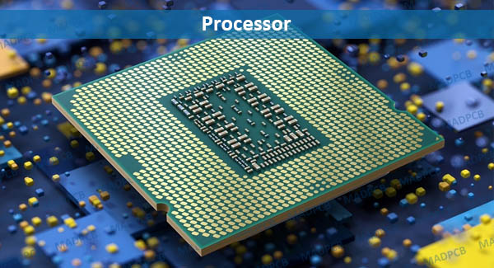

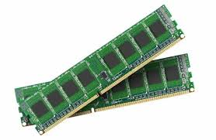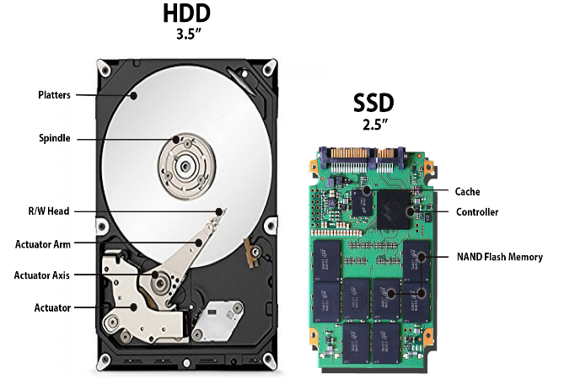

- Switch off the computer. Remove the power supply cord from the power socket. Open the casing of the PCs available in the lab.
The computer was properly shut down and disconnected from the power source by removing the power supply cord. Since the system under observation was a laptop, opening of the chassis was not performed. Hardware information was obtained using system utilities and official manufacturer documentation instead of physical inspection.
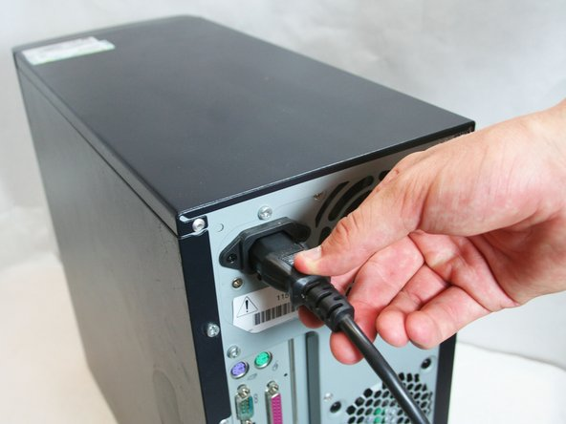

- Discover the power supply in the chassis. Record the type, model, power rating of the supply, and the available different voltage levels.
The system uses an external AC power adapter instead of an internal power supply unit. The power adapter converts alternating current (AC) into direct current (DC) required by the laptop components.
Power Supply Details:
- Type: External AC Power Adapter
- Model: Dell Laptop Power Adapter
- Power Rating: 65 Watts
- Input Voltage: 100–240V AC
- Output Voltage: 19.5V DC

- Discover about the motherboard chipset. Download its datasheet using the internet. Match the information found in the datasheet by physical inspection of the motherboard.
The motherboard chipset used in the system is Intel Q470. The chipset datasheet was downloaded from the official Intel website. The information provided in the datasheet, including processor support, memory type, and input/output interfaces, was matched with the system specifications obtained from the laptop

- Record the type and number of the following interfaces; Find their brief description from the datasheet.
  - PS/2
  - USB
  - Serial
  - Parallel
  - PCI
  - PCIe
  - AGP
  - VGA
  - HDMI
  - Audio
  - Ethernet
  - SATA and PATA
The following interfaces were identified in the system. Their functions were studied using the chipset datasheet and system documentation.
Interface | Type / Number | Description
PS/2 | Not Available | Legacy interface for keyboard and mouse
USB | 4 × USB 3.1 | Used to connect external peripherals
Serial | Not Available | Legacy communication interface
Parallel | Not Available | Old printer interface
PCI | Internal | Expansion interface for internal devices
PCIe | Internal | High-speed expansion interface
AGP | Not Available | Legacy graphics interface
VGA | 1 | Analog video display interface
HDMI | 1 | Digital audio and video interface
Audio | 1 Combo Jack | Input/output for sound devices
Ethernet | 1 | Wired network connection
SATA | Internal | Interface for storage devices
PATA | Not Available | Old hard disk interface

- Discover about the microprocessor and the socket type in which it is installed on the motherboard.
The system is equipped with an Intel Core i5-10210U microprocessor manufactured by Intel. The processor is installed using a BGA (Ball Grid Array) socket type, which means the processor is permanently soldered onto the motherboard and is not user-replaceable.

- Shed light on the memory hierarchy being employed in this PC. Fill in the following table.
The memory hierarchy is organized in such a way that the fastest and smallest memory is closest to the CPU, while larger and slower memory is placed further away. This structure improves overall system performance by balancing speed, capacity, and cost.
Memory Type | Size | Description
Registers | Few bytes | Registers are located inside the CPU and are the fastest memory units. They temporarily hold instructions and data currently being processed by the processor.
Cache | 6 MB | Cache memory is located inside the CPU and is used to store frequently accessed data to reduce access time. It includes L1, L2, and L3 cache levels.
RAM | 8 GB | Random Access Memory is the main memory of the system. It stores programs and data that are currently in use by the operating system and applications.
Disk Storage | 256 GB SSD | Disk storage is secondary memory used for permanent data storage. The SSD provides faster read and write operations compared to traditional hard disks.
Bottom of Form

Checked By: Date:

